E-COMMERCE CUSTOMER BEHAVIOUR ANALYSIS

1. Project Overview
This project focuses on analyzing an E-Commerce Customer Behavior Dataset containing 5,000 transaction records and 18 features. The dataset includes information about customer demographics, product categories, pricing, quantities, discounts, payment methods, device types, customer engagement, delivery time, and customer ratings.
The project follows an end-to-end data analytics process, starting with data loading and preprocessing in Python, followed by exploratory data analysis and visualization. The cleaned dataset is then used in Microsoft Power BI to create interactive dashboards for analyzing sales performance, customer behavior, and product and transaction patterns.
The overall purpose of this project is to transform raw e-commerce data into meaningful insights and business recommendations that can support better decision-making.
2. Project Objective
- To analyze e-commerce customer purchasing behavior.
- To clean and preprocess the raw dataset for accurate analysis.
- To evaluate sales performance across product categories and cities.
- To understand customer preferences based on payment methods and device types.
- To analyze the relationship between price, quantity, discounts, and sales.
- To identify important patterns, trends, and relationships using EDA and visualizations.
- To generate actionable business insights and recommendations using Python analysis and Power BI dashboards.
3. Project Outcome
The project provides an overall understanding of e-commerce sales performance and customer behavior through data analysis and visualization.
- The raw dataset was cleaned and prepared for analysis using Python.
- Exploratory Data Analysis was performed to identify important patterns, trends, and relationships.
- Different statistical and visual analysis techniques were used to understand sales, customers, products, and transactions.
- An interactive Power BI dashboard was developed to present key business metrics and analysis.
- The dashboard provides separate views for Sales Performance, Customer Behavior, and Product & Transaction Analysis.
- The analysis helps identify useful business insights that can support better decision-making.
4. Stage 1 – Data Loading & Initial Exploration
The dataset was loaded into the Python environment using Pandas for further analysis. The dataset contains 5,000 transaction records and 18 features related to customers, products, sales, payments, and purchasing behavior.
The initial exploration was performed to understand the structure and characteristics of the dataset. The following aspects were examined:
- The first few records were reviewed to understand the data.
- The number of rows and columns was identified.
- The data types of all features were checked.
- The overall dataset structure and available records were examined.
- Statistical information of numerical features was reviewed.
- Missing values were checked across all columns.
- Duplicate records were checked.
- All column names and their meaning were reviewed.
This initial exploration helped identify the structure and quality of the raw dataset and provided a foundation for the data preprocessing and cleaning stage.
5. Stage 2 – Data Pre-processing & Cleaning
The raw dataset was pre-processed to improve data quality and prepare it for accurate analysis. The following cleaning and transformation steps were performed:
5.1 Data Cleaning
- Checked the dataset for missing values.
- Checked for and handled duplicate records.
- Reviewed the data types of all columns.
- Converted the Date column into the appropriate date format.
- Verified and corrected numerical columns such as Unit Price, Quantity, Discount Amount, and Total Amount.
- Cleaned categorical columns by removing unnecessary spaces and checking their values.
- Checked numerical data for invalid or negative values.
5.2 Feature Engineering
Additional columns were created to support deeper analysis:
- Gross Amount – Calculated using Unit Price × Quantity.
- Discount Percentage – Calculated to understand the discount applied to each transaction.
- Year – Extracted from the order date.
- Month – Extracted from the order date.
- Month Name – Created for easier monthly analysis and visualization.
- Age Group – Customers were grouped into different age categories.
- Net Amount – Calculated after subtracting the discount from the gross amount.
6. Stage 3 – Exploratory Data Analysis
After completing the data preprocessing and cleaning, Exploratory Data Analysis (EDA) was performed to understand the patterns, relationships, trends, and distributions present in the e-commerce dataset.
6.1 Univariate Analysis
The following were analyzed:
- Product Category Distribution
- Age Distribution
- Total Amount Distribution
- Payment Method Distribution
- Customer Rating Distribution
- Gender Distribution
- Delivery Time Distribution
6.2 Bivariate Analysis
- Unit Price vs Total Amount
- Total Sales by City
- Sales by Payment Method
- Discount vs Total Amount
- Sales by Product Category
- Average Sales by Product Category and Customer Type
6.3 Multivariate Analysis
- Pairplot of important numerical features
- Correlation Heatmap
- Pivot table analysis
- Grouped analysis
6.4 Trend and Statistical Analysis
- Monthly Sales Trend
- Descriptive statistics of sales by product category
- Sales comparison across cities and categories
- Customer engagement analysis
- Diagnostic analysis of discount and sales relationships
7. Stage 4 – Documentation , Insights and presentation
Create a PDF pasting your DASHBOARD, explaining all the above mentioned concepts and submit it After completing the data analysis in Python, the cleaned dataset was imported into Microsoft Power BI to create an interactive dashboard. The dashboard was organized into three analytical sheets to provide a clear view of sales, customer behavior, and product transactions.
7.1 Power BI Measures Used
The following DAX measures were created for calculating important business metrics:
- Total Sales – Calculates the overall sales amount.
- Total Orders – Calculates the total number of transaction records.
- Average Order Value – Calculates the average value of an order.
- Returning Orders – Calculates the number of orders made by returning customers.
These measures were used mainly for the KPI cards and dashboard analysis.
7.2 Sheet 1 – Sales Performance Analysis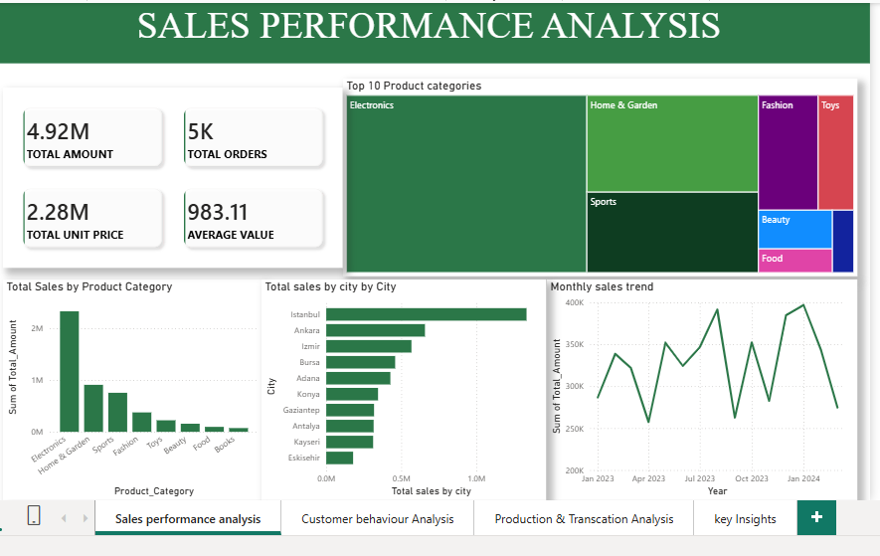
This sheet focuses on overall sales performance and helps understand where sales are generated.
Visuals included:
- Total Sales KPI
- Total Orders KPI
- Average Order Value KPI
- Sales by Product Category
- Total Sales by City
- Monthly Sales Trend
- Top 5 Product Categories by Sales
This sheet provides an overall view of sales performance across different categories, cities, and time periods.
7.3 Sheet 2 – Customer Behavior Analysis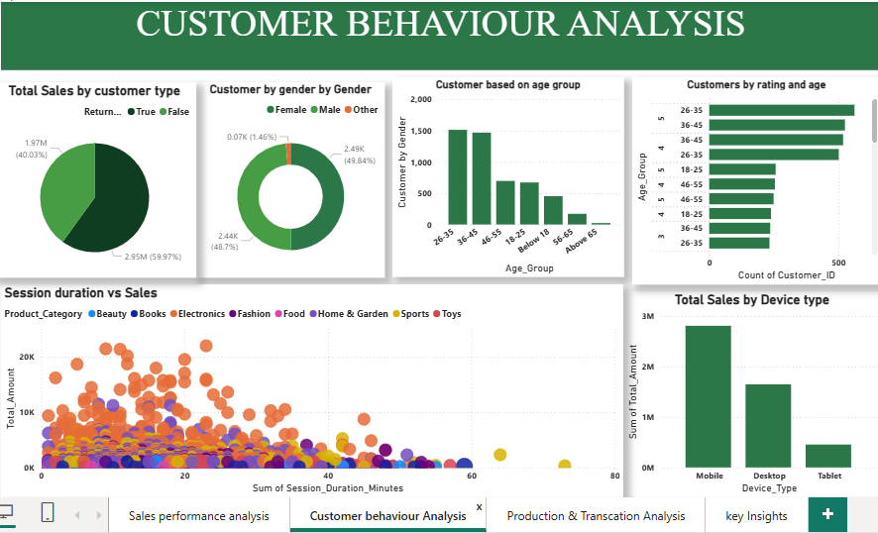
This sheet focuses on customer characteristics, purchasing behavior, and engagement.
Visuals included:
- Returning vs Non-Returning Orders
- Sales by Device Type
- Gender Distribution
- Age Group Distribution
- Customer Rating Distribution
- Session Duration vs Sales
This analysis helps understand customer segments, preferred devices, engagement levels, and customer satisfaction.
7.4 Sheet 3 – Product & Transaction Analysis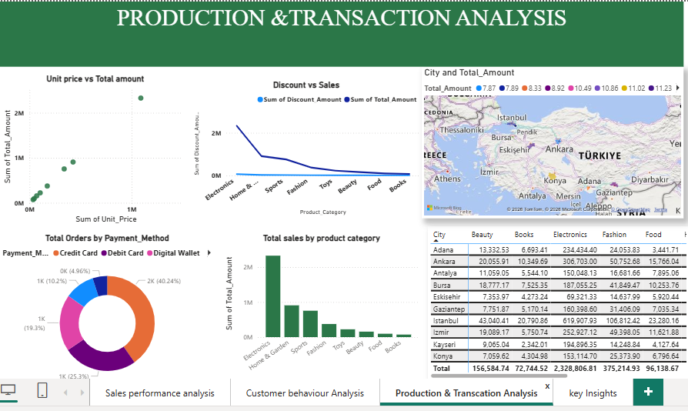
This sheet focuses on transaction-level patterns, payment preferences, pricing, discounts, and product sales.
Visuals included:
- Orders by Payment Method
- Unit Price vs Total Amount
- Discount vs Total Amount
- Quantity Distribution
- Sales by Product Category
- Sales by City Map
This sheet provides a detailed view of product and transaction-related performance.
8. Key Insights
Based on the Python EDA and Power BI dashboard analysis, the following key insights were identified:
- Product categories showed differences in sales performance, helping identify stronger and weaker-performing categories.
- City-wise sales analysis revealed variations in sales contribution across different locations.
- Monthly sales analysis helped identify changes and trends in sales performance over time.
- Payment method analysis showed differences in customer preferences for completing transactions.
- Device analysis provided an understanding of how customers access the e-commerce platform.
- Returning customer analysis helped compare the purchasing behavior of returning and non-returning customers.
- Customer ratings and delivery time provided useful information about customer satisfaction and service experience.
- Price, quantity, discount, and total sales showed important relationships that can help businesses understand transaction behavior.
- Customer engagement metrics, such as session duration and pages viewed, provided additional insight into online shopping behavior

9. Business Recommendations and Future Enhancements
Based on the analysis, the following recommendations can be considered:
- Focus on high-performing product categories and develop suitable strategies to increase their sales.
- Identify low-performing categories and cities and improve their marketing and promotional activities.
- Use customer behavior data to create targeted offers and personalized recommendations.
- Encourage returning customers through loyalty programs, special discounts, and personalized offers.
- Provide multiple payment options to improve customer convenience.
- Optimize the shopping experience across different device types, especially commonly used devices.
- Monitor discount strategies to increase sales while maintaining profitability.
- Improve delivery performance to support better customer satisfaction and ratings.
- Use customer engagement information such as session duration and pages viewed to improve the online shopping experience

10. Conclusion
This project successfully analyzed an E-Commerce Customer Behavior Dataset using an end-to-end data analytics approach
The project started with data loading and initial exploration, followed by data preprocessing and cleaning to improve the quality and reliability of the dataset. Exploratory Data Analysis was then performed using statistical techniques and visualizations to identify important patterns, trends, and relationships.
The cleaned data was further used to develop an interactive Power BI dashboard covering Sales Performance, Customer Behavior, and Product & Transaction Analysis. The dashboard provides a clear and visual way to understand key business metrics and customer purchasing patterns.
Overall, the project demonstrates how Python, data analysis, visualization, and Power BI can be combined to transform raw e-commerce data into meaningful insights and support data-driven business decision-making

